Alan Chow
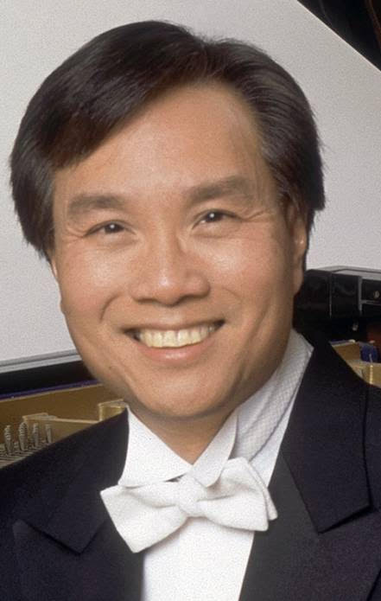
Acclaimed for his “elegant poetry and virtuosic fire,” Alan Chow has won First Prize in the Concert Artists Guild International Competition, the UCLA International Piano Competition, and the Palm Beach Invitational International Piano Competition. Winner of the Silver Medal and Audience Favorite Prize at the Gina Bachauer International Piano Competition, he was also a prizewinner in the William Kapell International Piano Competition.
A Steinway artist, Mr. Chow has performed in recital and in concert with orchestras from coast to coast in more than 45 states. His recitals have brought him to the major music centers including New York (Lincoln Center, Merkin Hall, Steinway Hall), Boston, Los Angeles, Chicago (Symphony Center and Ravinia), Washington, D.C., Cleveland, Seattle, Atlanta, New Orleans, and Miami. Concerto performances include appearances with the National Symphony, Utah Symphony, Oakland Symphony, Tulsa Philharmonic, Kansas City Symphony, and Omaha Symphony. Mr. Chow regularly tours Asia with performances in China, Japan, Hong Kong, Taiwan, and Singapore, including performances with the Hong Kong Philharmonic, Shanghai Philharmonic and the Pan-Asia Symphony. An avid chamber musician, he has collaborated with the American, Pacifica and Miami String Quartets and has been guest artist at the Grand Canyon Chamber Music Festival, Juneau Jazz and Classics, San Juan Islands Chamber Music Festival, Kent Blossom Music Festival, Texas Music Festival, Music Festival of Arkansas and Music Mountain. In addition, he appears in joint recital engagements in the Cheng-Chow Trio with pianists Angela Cheng and Alvin Chow.
Also in demand for his teaching, Mr. Chow has given master classes throughout North America and Asia at conservatories, universities and summer festivals including the Eastman School of Music, Indiana University, New Orleans International Piano Festival, Gina Bachauer International Piano Festival, Las Vegas Piano Festival, Tunghai International Piano Festival (Taiwan), and in Singapore. Appointed guest professor at the Central Conservatory in Beijing and honored visiting professor at the Shenyang Conservatory, he has also presented recitals, master classes, and lectures in China at the conservatories in Shanghai, Chengdu, Xian and Wuhan.
Mr. Chow studied with Nelita True at the University of Maryland where he graduated Co-Valedictorian with his twin brother Alvin, and received the Charles Manning Prize in the Creative and Performing Arts given to the outstanding graduate; with Sascha Gorodnitzki at The Juilliard School where he was awarded the Victor Herbert Prize in Piano; and with Menahem Pressler at Indiana University where he was the recipient of the Joseph Battista Memorial Scholarship. He also studied at the Mozarteum Sommerakademie with Carlo Zecchi.
Formerly on the faculty of the University of Arkansas and Northwestern University, Mr. Chow is currently on the artist faculty at the Eastman School of Music.

Jane McGrath
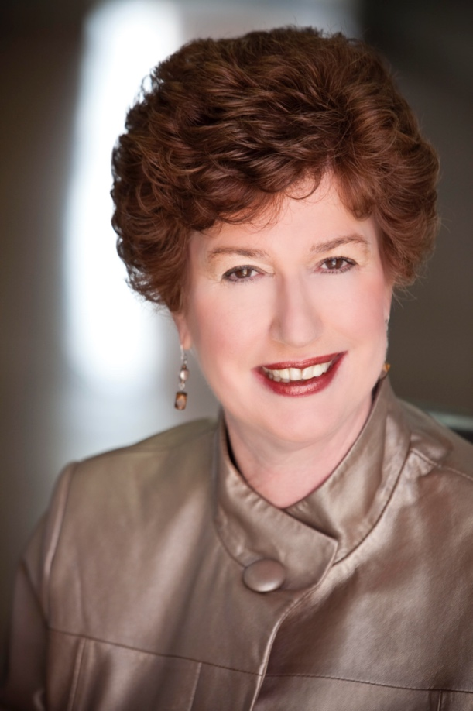
Jane Magrath is internationally known as an author, clinician, and pianist. Her book The Pianist's Guide to Standard Teaching and Performance Literature has become a classic reference work for pianists throughout the United States and abroad, and Magrath's work in the area of the standard classical teaching literature has been central to the current revival of interest in this music throughout the U.S. Shea introduced a leveling system of learning piano that is now a standard widely used throughout the nation. Magrath also is known for her varied piano literature editions through Alfred Publishing Co. that are used widely in the US and abroad.
Dr. Magrath is frequently in demand as a clinician and teacher. She has performed and given presentations throughout the world including Europe, Canada, Australia, Korea, Malaysia and New Zealand where her workshops and master classes have drawn strong acclaim. Magrath has served as Piano Coordinator for National Conventions of Music Teachers National Association and given presentations at MTNA National Conventions, the European Piano Teachers Association Conference, the National Conference on Piano Pedagogy, the World Piano Pedagogy Conference and at many state MTNA conventions. Her articles have appeared in the major piano journals. During various periods, she contributed New Music Reviews to Clavier, the column Polyphony to The American Music Teacher and a column Musings to Clavier Companion. She was named the first recipient of the MTNA/Frances Clark Keyboard Pedagogy Award for an Outstanding Contribution to Piano Pedagogy. Magrath currently directs the two-week Piano Seminar affiliated with the Classical Music Festival each August in Eisenstadt, Austria.
Magrath was the first person to receive the DM in Piano Performance and Pedagogy from Northwestern University and also received the MM at the University of North Carolina-Chapel Hill and the BM from Wesleyan College. She has received a Regents' Award for Superior Teaching, the Associates' Distinguished Lectureship Award, and the Rinsland Award for Excellence in Educational Research. Magrath also was named McCasland Presidential Professor, Rothbaum Presidential Professor, Oklahoma Music Teachers Association Teacher of the Year, and Oklahoma Musician of the Year by the Oklahoma Federation of Music Clubs. In 2009 she received the Neustadt Award from the University, given to an advocate for students and nominated by students. In 2016 she was inducted into the Oklahoma Heritage Society Higher Education Hall of Fame.
Currently, Magrath is Regents' Professor and holds the Grant Endowed Chair in Piano Pedagogy at the University of Oklahoma, where serves as Director of Piano Pedagogy. Students and former students have been placed in university and college teaching positions throughout the US, and many have won numerous prizes and competitions.

Naoki Hakutani
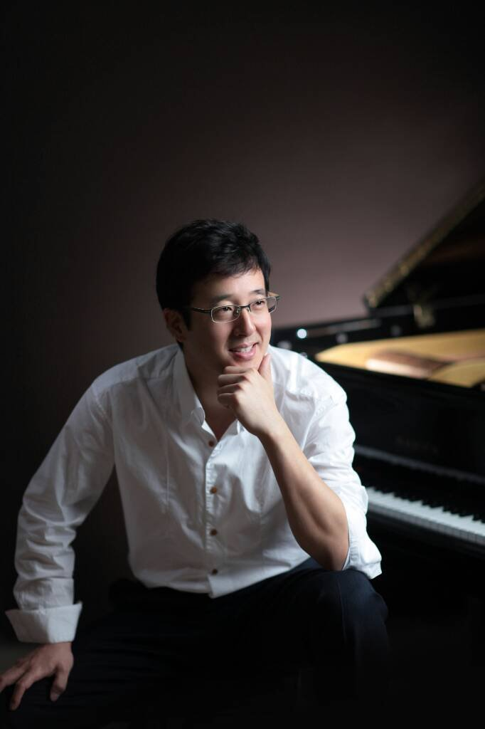
Originally from Kent, Ohio, Naoki Hakutani is currently an Associate Professor of Piano at the University of Arkansas at Little Rock. Dr. Hakutani is very active as a solo and collaborative pianist having performed throughout the United States and Asia. Dr. Hakutani holds degrees in piano performance from Northwestern University, Indiana University at Bloomington and the University of Texas at Austin.

Michael Caysido
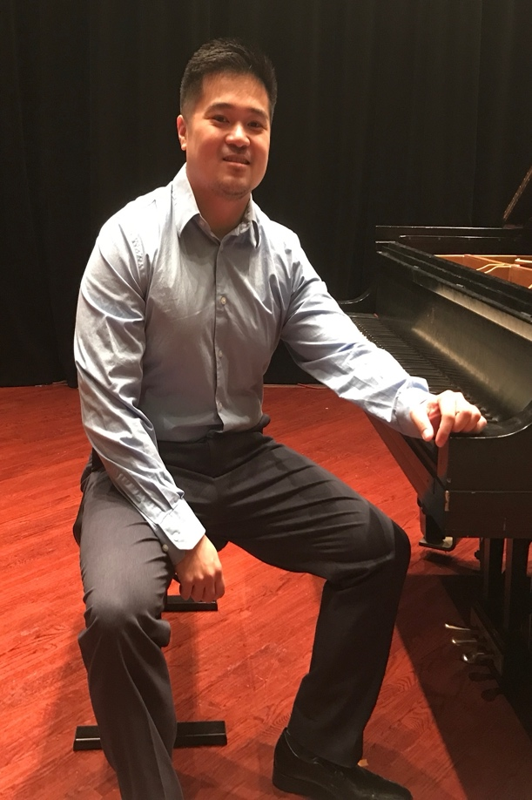
Michael Caysido is attending the University of Arkansas at Little Rock Department of Music under the tutelage of Dr. Naoki Hakutani. He is working on attaining his Bachelors in Music and his Bachelors in Nursing degrees. In addition, Michael is currently a Registered Nurse at CHI St. Vincent’s Infirmary in the Cardiovascular Intensive Care Unit. After graduation, Michael is planning on getting his Masters in Music and also his Masters in Certified Registered Nurse Anesthesia.

